Recruitment
Data Evaluation and Insights Manager

About The Mix
The Mix is a free, confidential support service for under 25s - making a massive difference to over two million young people in the UK each year. Whatever issue a young person is facing, The Mix is always there for them - online, over the phone or via social media. It connects young people to experts and their peers to talk about everything from money to mental health, from homelessness to jobs, from break-ups to drugs.
We are one of the eight charities forming the Duke and Duchess of Cambridge and Prince Harry’s Heads Together campaign to end stigma around mental health and will continue to work with them on raising awareness and providing vital help for people with mental health challenges. We work on high profile campaigns to change attitudes and raise awareness with the likes of Daniel Radcliff, Lady Gaga, and most recently Russell Brand. We work with TV shows like Hollyoaks to help young people understand sexual consent and big brands like River Island, Dixons Carphone and Lloyds Bank on everything from money to masturbation.
Today’s young people face an unprecedented range of challenges. They are possibly the first generation worse off in physical and emotional terms than their parents. The Mix’s mission is to ensure that every young person can make informed choices about their wellbeing – wherever and whenever they are: www.themix.org.uk
Vision, Mission and Values

What we do: The Mix is here to take on the embarrassing problems, weird questions, and please-don’t-make-me-say-it-out-loud thoughts that people under 25 have in order to give them the best support through our digital and phone services.
Vision: To be the first point of contact for under 25s. We know that with the right skills and opportunities, you can take on anything that life throws your way.
Mission: To empower everyone under 25 in the UK with the knowledge, skills and confidence to make the right first steps in life. Life is hard, but support doesn’t have to be.
Values:
- Empowering - we lead, we train & support, we respect, we give space to grow, we give power to chose
- Brave - we innovate, we pioneer, we take risks, we tell it how it is
- Supportive - we listen, we encourage, we care, we’re understanding, we are empathetic
- Collaborative - we are open & transparent, we co-create, we respect, experience & expertise
- Proactive - we create situations, we make things happen, we get things done
- Non-judgemental - we do not judge, we do not criticise, we do not blame

Job Description

Job title: Data Evaluation and Insights Manager
Reporting to: Deputy Director of Digital Services
Department: Digital Services

Overall Purpose of the job:
The Mix is looking for a full-time Data Evaluation and Insights Manager. The position is to oversee all aspects of data gathering, evaluation and impact to inform the charity’s service delivery teams, ensuring services are developed to match the needs identified in the data we collect.

The role will include Monitoring and Evaluation oversight through various channels.

The job holder has overall responsibility for capturing data pertaining to the charity monitoring performance against KPIs, evaluating impact and communicating this to key stakeholders.
The job holder will oversee a small team and will be responsible for people management, delegation, team development and performance management.

Main Areas of Responsibility

Lead on
- To develop and implement a monitoring and evaluation strategy using our existing Theory of Change that will improve existing reporting to internal and external stakeholders, help to identify areas for improvement, and increase employee engagement. This includes advising on format and timing of outputs, as well as direct responsibility for evaluation delivery, including record keeping, survey design, statistical analysis, report writing and dissemination.

- Leadership and management of the Data & Insight Team, including the Data Analyst role. Lead on effective people and performance management to ensure high standards of performance.

- To lead on the research pieces that The Mix commission across the organisation.

- Lead on continuation of the Data Consolidation Project, bringing together various methods of data capture and data storage technologies.

Support
- To support the organisation’s Data Protection Officer to inform and advise about our obligations to comply with the GDPR and other data protection laws.

- Supporting internal processes around GDPR compliance

Liaise
- Liaise with other members of the team on internal procedures and ensure effective working across the organisation.

Person Specification

We are looking for a dynamic individual with a real passion and enthusiasm for helping young people to improve their lives.

Essential
- Degree educated or 3 years’ experience in data and insight.
- Experience of developing and implementing organisation wide strategies
- Quantitative and qualitative research and analytical skills, including knowledge of relevant survey, analysis and reporting software.
- Aptitude for problem solving, methodical and highly numerate.
- Experience of managing a team, including delegation, team development, performance management.
- Commitment to team work, collaboration and a consultative approach to the delivery of work, but with an ability to work independently, show initiative and exercise sound judgement.
- Proficient in extracting the desired information from Google Analytics & CRM systems
- Knowledge of relevant research and evaluation methodologies, the Data Protection Act and other relevant rules and legislation concerning data, identity and privacy.
- High degree of competency in Microsoft Office, particularly Excel, and other databases, and a proven aptitude for learning new systems.
- Excellent time management, with the ability to work on multiple projects simultaneously and to tight deadlines

Desirable
- Project management experience.
- Experience with Salesforce reporting
- Experience with Watson Analytics
- Experience in SQL/MySQL reporting
- Strong understanding of how GDPR changes will affect charities

Attributes
- Delivery focused, self-motivated and ability to plan workload
- Good verbal and written communication and team player
Terms and Conditions

Salary: £35 - 40,000 pro rata - dependent on experience
Contract: Permanent

Location: The Mix, Binney Street, London
Pension 1% employee contribution secures 3% employers’ contribution to stakeholder pension scheme.
Hours: This post is full-time. Normal working hours are 9.30 – 5.30, Monday to Friday.
Some unsocial hours may be required including out of hours, evenings & weekend work for which time off in lieu may be given
Annual leave: You will be entitled to 35 days of holiday pro rata, which includes the 8 Statutory Bank Holiday during each year.

Benefits:
- Flexible and remote working available
- Childcare vouchers
- Eyecare vouchers
- Life assurance
- Weekly staff socials, plus Summer and Christmas Party
- Colleague of the month – awarded half a day extra annual leave
- Central London location
- Clinical supervision offered for front line services staff
- Coaching Environment
- Learning, development and training options
Employee Experience

Check out our `Meet our Staff` Video on our YouTube channel
https://www.youtube.com/user/TheSiteVideos/featured?disable_polymer=1

Testimonials
Nadia Inwood – Volunteer Manager
I’ve been working for The Mix now for around 4 years as the Volunteer Development Manager. I really enjoy my role and feel lucky that I work in an organisation that really fosters a positive, collaborative working ethos. On a daily basis I get to work across teams, I really feel this has been a big plus in my personal development. I’m lucky to work with a really great team of people who are all so passionate about what they do. The Mix has some really great benefits too, including weekly socials and opportunities for the staff to get together and have fun. Being a mum of two young children, I really value the flexibility The Mix offers with my working hours. I feel able to balance work and life just a little bit better. What I love the most, is that The Mix never stands still, I’m constantly learning and developing and know I’m making a difference.

Amina Abdillahi – Youth Support Officer
Before starting at The Mix as a Youth Support Officer, I was a volunteer here for about 3 years. What I loved most about volunteering here is how warm and friendly the helpline staff were. I felt lucky that I was able to meet people from all walks of life so when the role came up, I decided to give it a go. Having been a volunteer, I adapted to some things quicker than others. Thankfully the helpline team were very supportive and I was given time to learn the skills I would need to be successful. I enjoy the opportunity to work across other teams and get involved in their projects. The office itself is social and lively, there is definitely always someone to talk to and interact with.

How to apply

To apply, please send a CV and a covering letter addressing the attributes outlined in the Job Description and Person Specification to workforus@themix.org.uk.

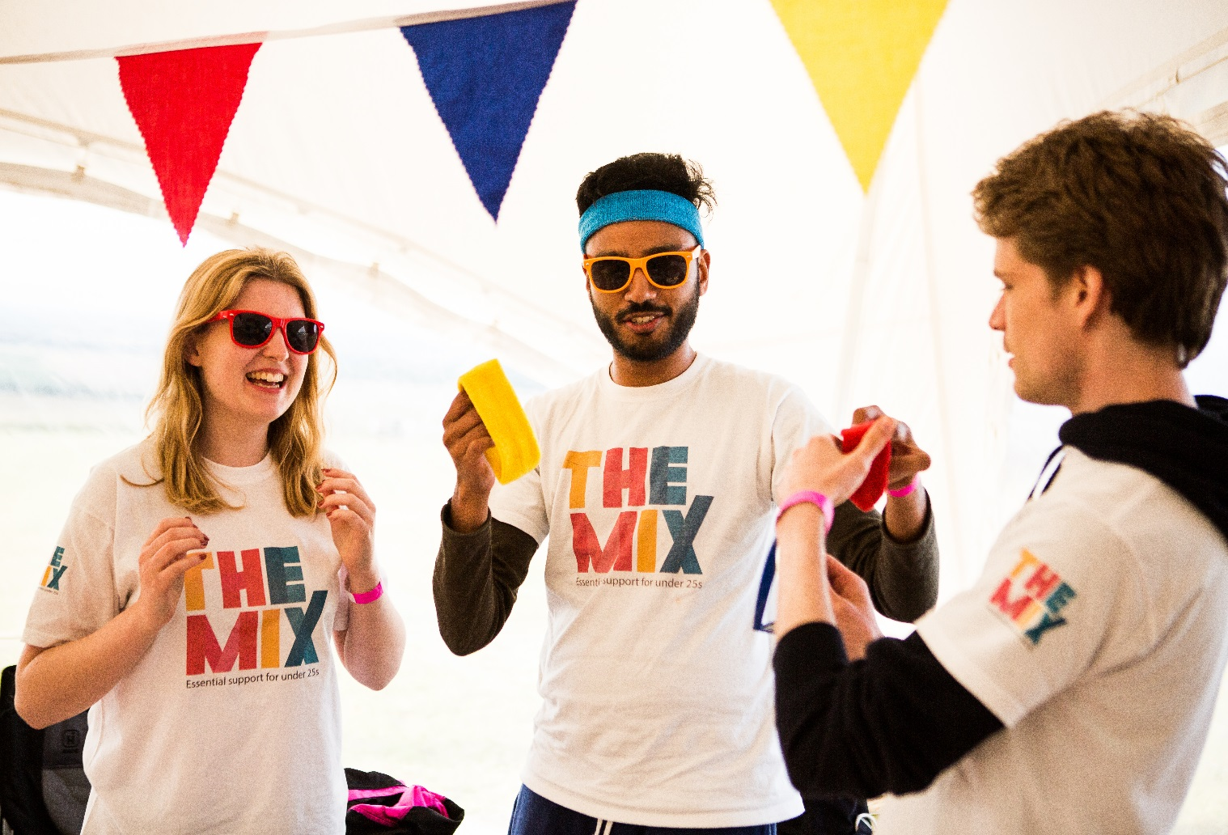
Have a look at our social media

Social Media

