Recruitment
Data Officer

About The Mix
The Mix is a free, confidential support service for under 25s - making a massive difference to over two million young people in the UK each year. Whatever issue a young person is facing, The Mix is always there for them - online, over the phone or via social media. It connects young people to experts and their peers to talk about everything from money to mental health, from homelessness to jobs, from break-ups to drugs.
We are one of the eight charities forming the Duke and Duchess of Cambridge and Prince Harry’s Heads Together campaign to end stigma around mental health and will continue to work with them on raising awareness and providing vital help for people with mental health challenges. We work on high profile campaigns to change attitudes and raise awareness with the likes of Daniel Radcliff, Lady Gaga, and most recently Russell Brand. We work with TV shows like Hollyoaks to help young people understand sexual consent and big brands like River Island, Dixons Carphone and Lloyds Bank on everything from money to masturbation.
Today’s young people face an unprecedented range of challenges. They are possibly the first generation worse off in physical and emotional terms than their parents. The Mix’s mission is to ensure that every young person can make informed choices about their wellbeing – wherever and whenever they are: www.themix.org.uk
Vision, Mission and Values

What we do: The Mix is here to take on the embarrassing problems, weird questions, and please-don’t-make-me-say-it-out-loud thoughts that people under 25 have in order to give them the best support through our digital and phone services.
Vision: To be the first point of contact for under 25s. We know that with the right skills and opportunities, you can take on anything that life throws your way.
Mission: To empower everyone under 25 in the UK with the knowledge, skills and confidence to make the right first steps in life. Life is hard, but support doesn’t have to be.
Values:
- Empowering - we lead, we train & support, we respect, we give space to grow, we give power to chose
- Brave - we innovate, we pioneer, we take risks, we tell it how it is
- Supportive - we listen, we encourage, we care, we’re understanding, we are empathetic
- Collaborative - we are open & transparent, we co-create, we respect, experience & expertise
- Proactive - we create situations, we make things happen, we get things done
- Non-judgemental - we do not judge, we do not criticise, we do not blame

Job Description

Job title: Data Officer
Reporting to: Data, Evaluation and Insights Manager
Department: Digital Services

Overall Purpose of the job:

The position is to undertake all aspects of data gathering, data analysis and data reporting to inform the charity’s service delivery, funding and future strategy.

Key areas of responsibility:
- To collect, analysis and present organisational data accurately and efficiently to effectively report on organisational and projects KPIs.
- Work across the charity, especially with the service delivery directorate, to collaboratively collect data and report it back to staff, volunteers, Trustee, external audiences and young people.
- Working closely with the Fundraising and Development team to report on and evaluate funded projects.
- Alongside the Database Manager, to ensure that all The Mix’s data compliant with the Data Protection Act 1998 and new GDPR guidelines.
- To keep abreast of and share developments in data collection, analysis and visualisation.
- To do other related duties to this role, as required.

Person Specification

We are looking for a dynamic individual with a real passion and enthusiasm for helping young people to improve their lives.
Essential
- Proven experience and skills in data collection, analysis, reporting and visualisation.
- High competency using Microsoft Office package and CRM databases
- Knowledge of Data Protection regulations and best working practices for data
- Good people skills, adaptable and flexible in manner and approach
- Good planning, problem solving and organisational skills.
- Good written and verbal communication.
- Ability to work on own initiative and as an active team member.
- Ability to work under pressure and in a fast-paced environment.
- Ability to take risks and learn from mistakes.
- A passion for working with young people.

Desirable
- Experience working with Salesforce, or similar database.
- Experience working with IBM Watson
- An understanding of safeguarding, confidentiality and safe working practices.

Attributes
- Delivery focused, self-motivated and ability to plan workload
- Good verbal and written communication and team player
Terms and Conditions

Salary: Up to £30,000 pro-rata per annum (depending on experience)
(£24,000)
Contract: Permanent

Location: The Mix, Binney Street, London
Pension 1% employee contribution secures 3% employers’ contribution to stakeholder pension scheme.
Hours: This post is four days a week (days to be agreed) Monday to Friday with 28 working hours a week. Occasional evening and weekend work will be required for which time of in lieu will be given.
Annual leave: You will be entitled to 35 days of holiday pro rata, which includes the 8 Statutory Bank Holiday during each year.

Benefits:
- Flexible and remote working available
- Childcare vouchers
- Eyecare vouchers
- Life assurance
- Weekly staff socials, plus Summer and Christmas Party
- Colleague of the month – awarded half a day extra annual leave
- Central London location
- Clinical supervision offered for front line services staff
- Coaching Environment
- Learning, development and training options
Employee Experience

Check out our `Meet our Staff` Video on our YouTube channel
https://www.youtube.com/user/TheSiteVideos/featured?disable_polymer=1

Testimonials
Nadia Inwood – Volunteer Manager
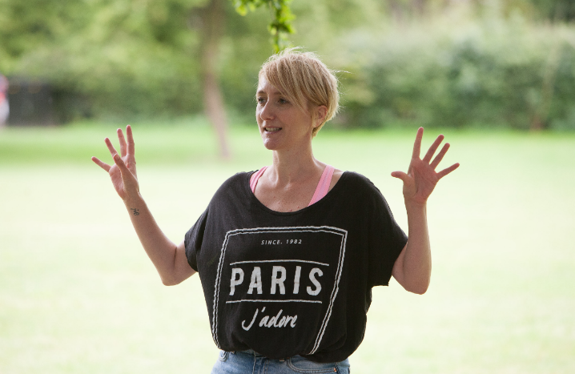
I’ve been working for The Mix now for around 4 years as the Volunteer Development Manager. I really enjoy my role and feel lucky that I work in an organisation that really fosters a positive, collaborative working ethos. On a daily basis I get to work across teams, I really feel this has been a big plus in my personal development. I’m lucky to work with a really great team of people who are all so passionate about what they do. The Mix has some really great benefits too, including weekly socials and opportunities for the staff to get together and have fun. Being a mum of two young children, I really value the flexibility The Mix offers with my working hours. I feel able to balance work and life just a little bit better. What I love the most, is that The Mix never stands still, I’m constantly learning and developing and know I’m making a difference.

Amina Abdillahi – Youth Support Officer
Before starting at The Mix as a Youth Support Officer, I was a volunteer here for about 3 years. What I loved most about volunteering here is how warm and friendly the helpline staff were. I felt lucky that I was able to meet people from all walks of life so when the role came up, I decided to give it a go. Having been a volunteer, I adapted to some things quicker than others. Thankfully the helpline team were very supportive and I was given time to learn the skills I would need to be successful. I enjoy the opportunity to work across other teams and get involved in their projects. The office itself is social and lively, there is definitely always someone to talk to and interact with.

How to apply

To apply, please send a CV and a covering letter addressing the attributes outlined in the Job Description and Person Specification to workforus@themix.org.uk.

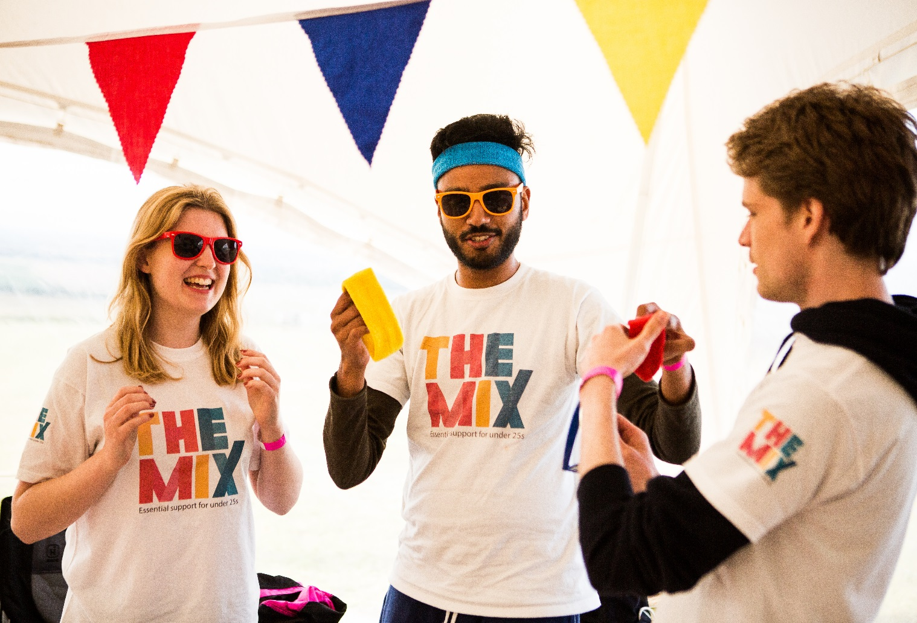
Have a look at our social media

Social Media

