

Digital Support Worker
(full time or part time)

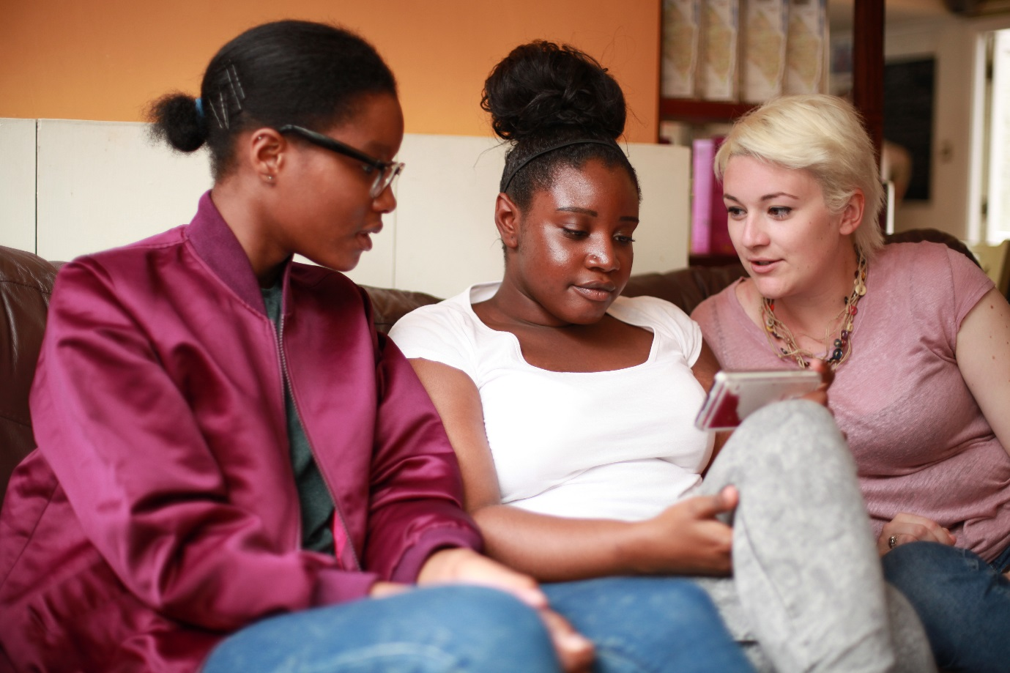

About The Mix
The Mix is a free, confidential support service for under 25s - making a massive difference to over two million young people in the UK each year. Whatever issue a young person is facing, The Mix is always there for them - online, over the phone or via social media. It connects young people to experts and their peers to talk about everything from money to mental health, from homelessness to jobs, from break-ups to drugs.
We are one of the eight charities forming the Duke and Duchess of Cambridge and Prince Harry’s Heads Together campaign to end stigma around mental health and will continue to work with them on raising awareness and providing vital help for people with mental health challenges. We work on high profile campaigns to change attitudes and raise awareness with the likes of Daniel Radcliff, Lady Gaga, and most recently Russell Brand. We work with TV shows like Hollyoaks to help young people understand sexual consent and big brands like River Island, Dixons Carphone and Lloyds Bank on everything from money to masturbation.
Today’s young people face an unprecedented range of challenges. They are possibly the first generation worse off in physical and emotional terms than their parents. The Mix’s mission is to ensure that every young person can make informed choices about their wellbeing – wherever and whenever they are: www.themix.org.uk
Vision, Mission and Values

What we do: The Mix is here to take on the embarrassing problems, weird questions, and please-don’t-make-me-say-it-out-loud thoughts that people under 25 have in order to give them the best support through our digital and phone services.
Vision: To be the first point of contact for under 25s. We know that with the right skills and opportunities, you can take on anything that life throws your way.
Mission: To empower everyone under 25 in the UK with the knowledge, skills and confidence to make the right first steps in life. Life is hard, but support doesn’t have to be.
Values:
- Empowering - we lead, we train & support, we respect, we give space to grow, we give power to chose
- Brave - we innovate, we pioneer, we take risks, we tell it how it is
- Supportive - we listen, we encourage, we care, we’re understanding, we are empathetic
- Collaborative - we are open & transparent, we co-create, we respect, experience & expertise
- Proactive - we create situations, we make things happen, we get things done
- Non-judgemental - we do not judge, we do not criticise, we do not blame

Job Description
Job title: Digital Support Worker
Department: Services
Reporting to: Service Manager

Overall Purpose of the job:
Manage the delivery of a volunteer led one-to-one support services providing emotional support and appropriate signposting currently delivered via telephone, webchat and email.

Key areas of responsibility:
- Support our volunteer body to efficiently and safely deliver high quality one to one support services
- Assist with the running of shift support and on-going training for helpline volunteers
- Oversee the rota for delivering one-to-one support services
- Oversee effective shift management
- Ensure appropriate training and development of volunteers with our Youth Engagement Team
- Ensure implementation of relevant The Mix policies and procedures so our services are delivered to the highest quality
- Contribute to data analysis to ensure services continuously responding to service user needs
- Support reflective practice and a culture of continuous development
- Oversee appropriate risk assessment and make decisions about when to breach confidentiality
- Resolve operational issues in the delivery of one-to-one support services
- Co-ordinate the management of regular and or concerning contacts
- Provide one to one support services as required
- Take part in the on-call rota, for which additional payment may be given (when not working)
- Management of staff and consultants as required
- Any other relevant duties as required

Person Specification

Essential
- Experience or interest in delivering support services via digital channels
- Ability to manage multiple tasks simultaneously, work flexibly and be able to work calmly under pressure
- Ability to maintain effective boundaries whilst delivering a service with empathy
- Ability to carry out objective risk assessments, liaising with emergency services as needed
- Strong demonstrable interest in the issues which affect young people
- Computer literate with good typing skills
- Proven ability to deliver continuous improvement to services in response to service user needs
- Understanding of how to train, motivate and develop volunteers
- Good understanding of safeguarding, confidentiality and safe working practices.
- Willingness to work face-to-face with young people and adults
- Self-starter with the ability to work on own initiative and as an active team member
- Excellent written and oral communication skills

Desirable
- Line management or volunteer management Experience
- Experience of multi-channel support services including email and webchat
- Experience using of using 8x8 / Salesforce or equivalent VOIP/CRM systems
- Experience of delivering support services to under 25s
- Project management experience

Terms and Conditions
Salary: Up to £24,500 per annum pro rata (depending on experience)
Contract: Permanent
Location: The Charity’s service hub, currently Glentworth Street, London, NW1 with the opportunity for some remote working
Pension: 2% employee contribution secures 4% employers’ contribution to stakeholder pension scheme.
Hours: This post is available full-time (35 hours) or part time (16 hours, 16.5 hours, 20 hours or 22 hours). Hours are between 3pm-11pm. The service operates seven days a week and working days would need to be agreed.
Annual leave: You will be entitled to 35 days of holiday pro rata, which includes the 8 Statutory Bank Holiday during each year.

Benefits:
- Flexible and remote working available
- Childcare vouchers
- Eyecare vouchers
- Life assurance
- Weekly staff socials, plus Summer and Christmas Party
- Colleague of the month – awarded half a day extra annual leave (pro rota)
- Central London location
- Clinical supervision offered for front line services staff
- Coaching Environment
- Learning, development and training options

Check out our `Meet our Staff` Video on our YouTube channel
https://www.youtube.com/user/TheSiteVideos/featured?disable_polymer=1

Testimonials
Nadia Inwood – Volunteer Manager
I’ve been working for The Mix now for around 4 years as the Volunteer Development Manager. I really enjoy my role and feel lucky that I work in an organisation that really fosters a positive, collaborative working ethos. On a daily basis I get to work across teams, I really feel this has been a big plus in my personal development. I’m lucky to work with a really great team of people who are all so passionate about what they do. The Mix has some really great benefits too, including weekly socials and opportunities for the staff to get together and have fun. Being a mum of two young children, I really value the flexibility The Mix offers with my working hours. I feel able to balance work and life just a little bit better. What I love the most, is that The Mix never stands still, I’m constantly learning and developing and know I’m making a difference.

Amina Abdillahi – Youth Support Officer
Before starting at The Mix as a Youth Support Officer, I was a volunteer here for about 3 years. What I loved most about volunteering here is how warm and friendly the helpline staff were. I felt lucky that I was able to meet people from all walks of life so when the role came up, I decided to give it a go. Having been a volunteer, I adapted to some things quicker than others. Thankfully the helpline team were very supportive and I was given time to learn the skills I would need to be successful. I enjoy the opportunity to work across other teams and get involved in their projects. The office itself is social and lively, there is definitely always someone to talk to and interact with.

To apply, please send a CV and a covering letter addressing the attributes outlined in the Job Description and Person Specification to workforus@themix.org.uk.




