

Service Manager

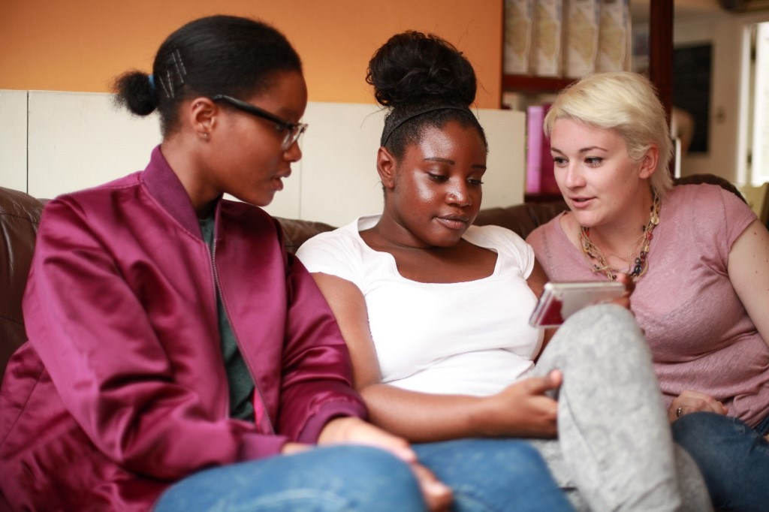

The Mix is a free, confidential support service for under 25s - making a massive difference to over two million young people in the UK each year. Whatever issue a young person is facing, The Mix is always there for them - online, over the phone or via social media. It connects young people to experts and their peers to talk about everything from money to mental health, from homelessness to jobs, from break-ups to drugs.

We are one of the eight charities forming the Duke and Duchess of Cambridge and Prince Harry’s Heads Together campaign to end stigma around mental health and will continue to work with them on raising awareness and providing vital help for people with mental health challenges. We work on high profile campaigns to change attitudes and raise awareness with the likes of Daniel Radcliff, Lady Gaga, and most recently Russell Brand. We work with TV shows like Hollyoaks to help young people understand sexual consent and big brands like River Island, Dixons Carphone and Lloyds Bank on everything from money to masturbation.

Today’s young people face an unprecedented range of challenges. They are possibly the first generation worse off in physical and emotional terms than their parents. The Mix’s mission is to ensure that every young person can make informed choices about their wellbeing – wherever and whenever they are: www.themix.org.uk

What we do: The Mix is here to take on the embarrassing problems, weird questions, and please-don’t-make-me-say-it-out-loud thoughts that people under 25 have in order to give them the best support through our digital and phone services.
Vision: To be the first point of contact for under 25s. We know that with the right skills and opportunities, you can take on anything that life throws your way.
Mission: To empower everyone under 25 in the UK with the knowledge, skills and confidence to make the right first steps in life. Life is hard, but support doesn’t have to be.
Values:
- Empowering - we lead, we train & support, we respect, we give space to grow, we give power to chose
- Brave - we innovate, we pioneer, we take risks, we tell it how it is
- Supportive - we listen, we encourage, we care, we’re understanding, we are empathetic
- Collaborative - we are open & transparent, we co-create, we respect, experience & expertise
- Proactive - we create situations, we make things happen, we get things done
- Non-judgemental - we do not judge, we do not criticise, we do not blame

Job title: Service Manager
Department: Services
Reporting to: Deputy Director of Services

Overall Purpose of the job:
Deliver and manage a team to provide effective one to one support, currently delivered by phone, webchat and email, to young people.

Key areas of responsibility:
- Oversee the high quality delivery and development of one to one support for young people
- Implement new initiatives and lean practices to maximise contact taking
- Lead data-led service improvement, ensuring effectively policy and procedure is in place
- Co-ordinate a young persons’ steering group to ensure user-centred service development
- Develop and implement effective quality assurance mechanisms to ensure current and future services are delivered to the highest quality
- Ensure all support service delivery is in line with legal, ethical, regulatory and social requirements
- Provide leadership and direction for the support team ensuring service needs are met
- Provide one to one support services, including contact taking and shift leading duties, when needed
- Work closely with the youth engagement team to ensure volunteers are effectively recruited, trained, developed and retained
- Lead the integration of one to one support, ensuring support is represented across The Mix
- Ensure all support channels are appropriately staffed and resourced
- Direct line management of Digital Support Workers
- Contribute to the development of funding proposals to enhance and extend the work of The Mix
- Project management of support services projects, including reporting and funder meetings as needed
- Take part in the on call rota, for which additional payment may be given
- Any other duties as required

Essential
- Experience of service delivery to under 25s with a strong interest in the issues affecting them
- Experience of managing, developing and delivering volunteer-led support services
- Ability to lead a service that is continuously developing in response to service user needs.
- Experience of using CRM and/ or VCCs and trouble-shooting / resolving technical issues
- Understanding of how to motivate and develop staff
- Experience of line management
- Demonstrable understanding of safeguarding, confidentiality and safe working practices.
- Understanding of quality assurance mechanisms for service delivery
- Ability to manage multiple tasks simultaneously, work flexibly and able to work calmly and with patience under pressure
- Ability to maintain effective boundaries whilst delivering a service with empathy
- Self-starter with the ability to work on own initiative and as an active team member
- Strong computer literacy with excellent written and oral communication skills

Desirable
- Experience of helpline environment and operational requirements
- Experience of using 8x8 and Salesforce
- Project and budget management experience.
- Project management qualification
- Lean Thinking training

Salary: Up to £31,000 per annum pro rata (depending on experience)
Contract: Permanent
Location: The Charity’s service hub, currently Glentworth Street, London, NW1
Pension: 2% employee contribution secures 4% employers’ contribution to stakeholder pension scheme.
Hours: This post is full-time, Monday to Friday 12pm-8pm (excluding Thursdays, which would be 10pm-6pm). This role will require evening and weekend work for which time off in lieu will be given.
Annual Leave: You will be entitled to 35 days of holiday pro rata, which includes the 8 Statutory Bank Holiday during each year.

Benefits:
- Flexible and remote working available
- Childcare vouchers
- Eyecare vouchers
- Life assurance
- Weekly staff socials, plus Summer and Christmas Party
- Colleague of the month – awarded half a day extra annual leave
- Central London location
- Clinical supervision offered for front line services staff
- Coaching Environment
- Learning, development and training options

Check out our `Meet our Staff` Video on our YouTube channel
https://www.youtube.com/user/TheSiteVideos/featured?disable_polymer=1

Testimonials
Nadia Inwood – Volunteer Manager
I’ve been working for The Mix now for around 4 years as the Volunteer Development Manager. I really enjoy my role and feel lucky that I work in an organisation that really fosters a positive, collaborative working ethos. On a daily basis I get to work across teams, I really feel this has been a big plus in my personal development. I’m lucky to work with a really great team of people who are all so passionate about what they do. The Mix has some really great benefits too, including weekly socials and opportunities for the staff to get together and have fun. Being a mum of two young children, I really value the flexibility The Mix offers with my working hours. I feel able to balance work and life just a little bit better. What I love the most, is that The Mix never stands still, I’m constantly learning and developing and know I’m making a difference.

Amina Abdillahi – Youth Support Officer
Before starting at The Mix as a Youth Support Officer, I was a volunteer here for about 3 years. What I loved most about volunteering here is how warm and friendly the helpline staff were. I felt lucky that I was able to meet people from all walks of life so when the role came up, I decided to give it a go. Having been a volunteer, I adapted to some things quicker than others. Thankfully the helpline team were very supportive and I was given time to learn the skills I would need to be successful. I enjoy the opportunity to work across other teams and get involved in their projects. The office itself is social and lively, there is definitely always someone to talk to and interact with.

To apply, please send a CV and a covering letter addressing the attributes outlined in the Job Description and Person Specification to workforus@themix.org.uk.




