Recruitment
Video Producer

About The Mix
The Mix is a free, confidential support service for under 25s - making a massive difference to over two million young people in the UK each year. Whatever issue a young person is facing, The Mix is always there for them - online, over the phone or via social media. It connects young people to experts and their peers to talk about everything from money to mental health, from homelessness to jobs, from break-ups to drugs.
We are one of the eight charities forming the Duke and Duchess of Cambridge and Prince Harry’s Heads Together campaign to end stigma around mental health and will continue to work with them on raising awareness and providing vital help for people with mental health challenges. We work on high profile campaigns to change attitudes and raise awareness with the likes of Daniel Radcliff, Lady Gaga, and most recently Russell Brand. We work with TV shows like Hollyoaks to help young people understand sexual consent and big brands like River Island, Dixons Carphone and Lloyds Bank on everything from money to masturbation.
Today’s young people face an unprecedented range of challenges. They are possibly the first generation worse off in physical and emotional terms than their parents. The Mix’s mission is to ensure that every young person can make informed choices about their wellbeing – wherever and whenever they are: www.themix.org.uk
Vision, Mission and Values

What we do: The Mix is here to take on the embarrassing problems, weird questions, and please-don’t-make-me-say-it-out-loud thoughts that people under 25 have in order to give them the best support through our digital and phone services.
Vision: To be the first point of contact for under 25s. We know that with the right skills and opportunities, you can take on anything that life throws your way.
Mission: To empower everyone under 25 in the UK with the knowledge, skills and confidence to make the right first steps in life. Life is hard, but support doesn’t have to be.
Values:
- Empowering - we lead, we train & support, we respect, we give space to grow, we give power to chose
- Brave - we innovate, we pioneer, we take risks, we tell it how it is
- Supportive - we listen, we encourage, we care, we’re understanding, we are empathetic
- Collaborative - we are open & transparent, we co-create, we respect, experience & expertise
- Proactive - we create situations, we make things happen, we get things done
- Non-judgemental - we do not judge, we do not criticise, we do not blame

Job Description

Job title Video Producer
Department Marcomms
Reporting to Editorial Communications Manager
Overall Purpose of the job:
To create compelling and engaging video content for young people and other stakeholders at The Mix.

Key areas of responsibility:
- To create compelling film content to be used in campaigns, as a part of projects and to actively support young people and promote The Mix in line with our strategy
- Work with the marketing team to create optimised video for social, including Facebook, Twitter and Instagram, demonstrating an understanding of formatting, correct specs, subtitling and re-purposing existing content for a social audience
- To identify and support young up-and-coming vloggers to produce high-quality information and advice content while driving up views and subscribers
- To manage and grow The Mix’s YouTube channel
- To provide filming support to all teams at The Mix, including production videos for external clients, funders and other key stakeholders and for social media.
- Plan, organise and execute the filming, editing and production of videos, including the sourcing of locations, freelancers, actors and young volunteers
- Ensure existing multimedia content is well maintained and stays updated across our channels
- Organise and execute the filming of internal and external events
- Write treatments and/ or scripts when necessary
- Execute photoshoots
- Any other duties as required
Person Specification

Person Specification:
Essential
- Experienced film and audio editor, with an excellent working knowledge of Premiere Pro and the Adobe Creative Suite
- Knowledge and experience with cameras, lighting, microphones for studio set up and video production, including DSLR cameras (GH4)
- Good understanding of video production and distribution for web
- Experience of capturing and editing still imagery for web
- Creative, with the ability to write engaging and relevant scripts that tackle issues young people are facing
- Strong interest in the issues which affect young people
- Organised and able to manage a range of competing priorities
- Self-starter with the ability to work on own initiative and as an active team member
- Flexible, adaptable and willing to learn
- Ability to manage the feedback process from key stakeholders and implement relevant amends effectively

Desirable
- Experience of YouTube channel management
- Motion graphics skill, After Effects proficiency
- Experience working with stakeholders, preferably young people, to help them produce their own video content
- Experience working with vloggers, or links to the YouTuber community
- Experience of producing shareable graphic content, e.g. infographics
- Good spelling and grammar
- Experience of managing volunteers, work experience people and interns;
- Experience running shoots
- Experience of briefing freelancer or agencies
Terms and Conditions

Salary: £20,000-22,000 per annum pro rata (depending on experience)
Contract: Permanent/Fixed Term

Location: The Mix’s service hub, currently in Glentworth Street, London, NW1
Pension 2% employee contribution secures 4% employers’ contribution to stakeholder pension scheme.
Hours: This post is full time Monday to Friday with 35 working hours a week. Occasional evening and weekend work will be required for which time of in lieu will be given.
Annual leave: You will be entitled to 35 days of holiday pro rata, which includes the 8 Statutory Bank Holiday during each year.

Benefits:
- Flexible and remote working available
- Childcare vouchers
- Eyecare vouchers
- Life assurance
- Weekly staff socials, plus Summer and Christmas Party
- Colleague of the month – awarded half a day extra annual leave
- Central London location
- Clinical supervision offered for front line services staff
- Coaching Environment
- Learning, development and training options
Employee Experience

Check out our `Meet our Staff` Video on our YouTube channel
https://www.youtube.com/user/TheSiteVideos/featured?disable_polymer=1

Testimonials
Nadia Inwood – Volunteer Manager
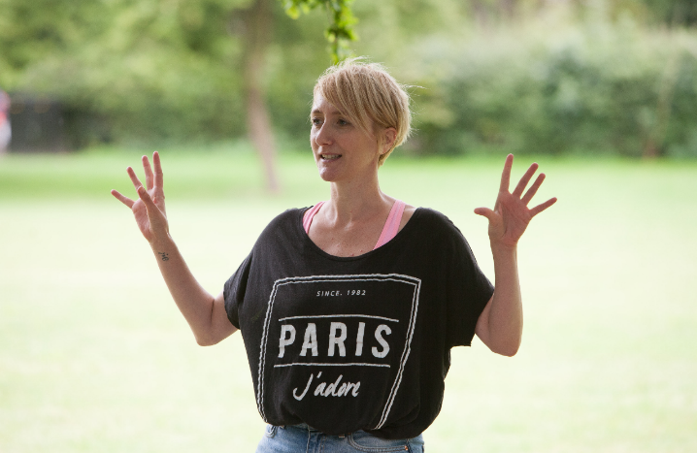
I’ve been working for The Mix now for around 4 years as the Volunteer Development Manager. I really enjoy my role and feel lucky that I work in an organisation that really fosters a positive, collaborative working ethos. On a daily basis I get to work across teams, I really feel this has been a big plus in my personal development. I’m lucky to work with a really great team of people who are all so passionate about what they do. The Mix has some really great benefits too, including weekly socials and opportunities for the staff to get together and have fun. Being a mum of two young children, I really value the flexibility The Mix offers with my working hours. I feel able to balance work and life just a little bit better. What I love the most, is that The Mix never stands still, I’m constantly learning and developing and know I’m making a difference.

Amina Abdillahi – Youth Support Officer
Before starting at The Mix as a Youth Support Officer, I was a volunteer here for about 3 years. What I loved most about volunteering here is how warm and friendly the helpline staff were. I felt lucky that I was able to meet people from all walks of life so when the role came up, I decided to give it a go. Having been a volunteer, I adapted to some things quicker than others. Thankfully the helpline team were very supportive and I was given time to learn the skills I would need to be successful. I enjoy the opportunity to work across other teams and get involved in their projects. The office itself is social and lively, there is definitely always someone to talk to and interact with.
How to apply

To apply, please send a CV and a covering letter addressing the attributes outlined in the Job Description and Person Specification to workforus@themix.org.uk.

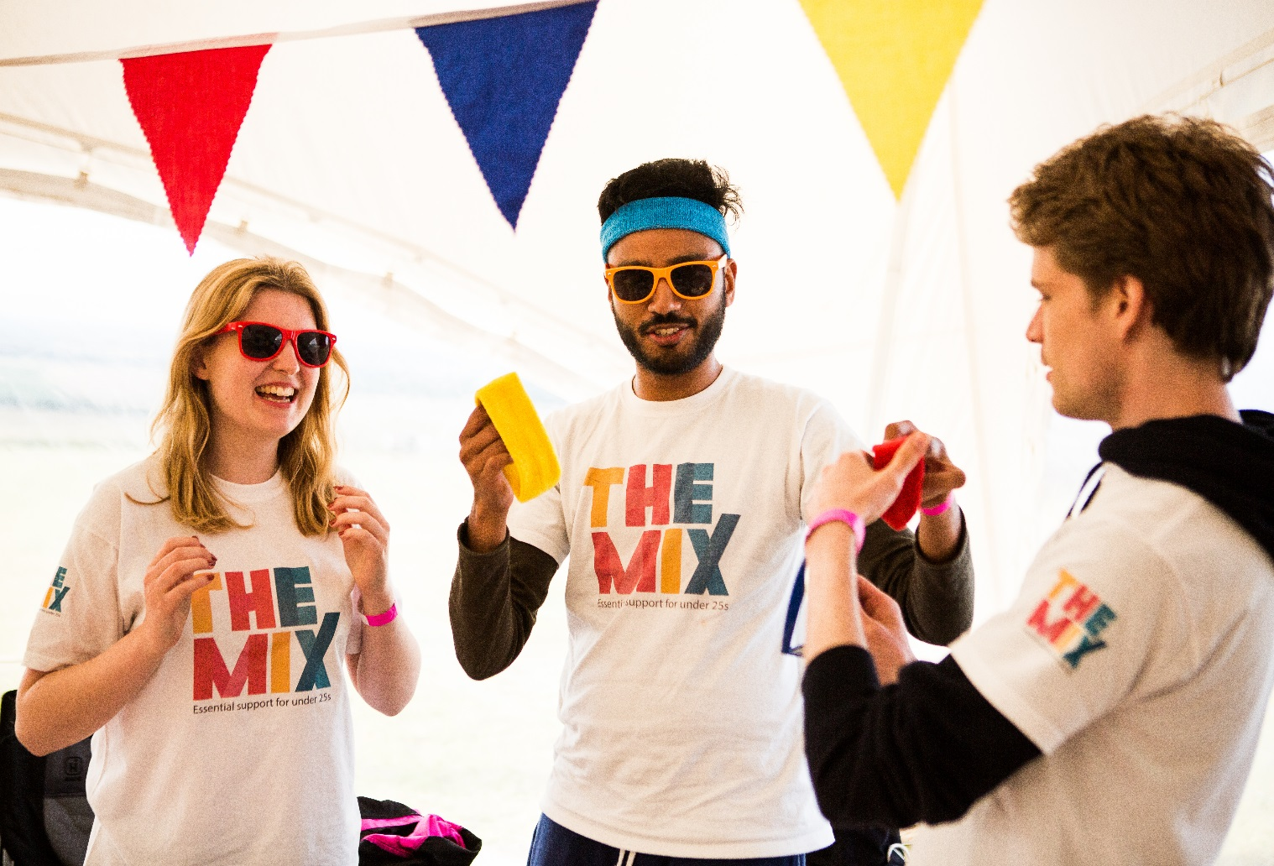
Have a look at our social media

Social Media

