

Head of Services

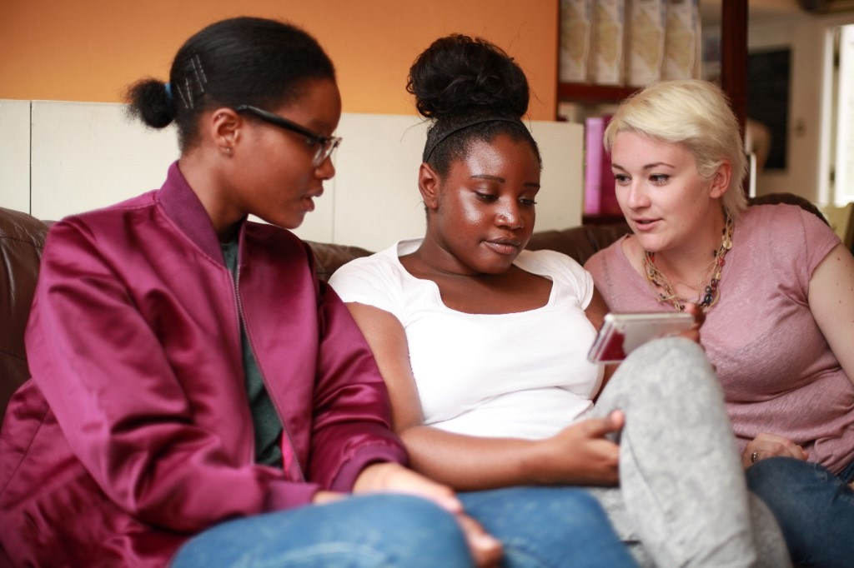

The Mix is a free, confidential support service for under 25s - making a massive difference to over two million young people in the UK each year. Whatever issue a young person is facing, The Mix is always there for them - online, over the phone or via social media. It connects young people to experts and their peers to talk about everything from money to mental health, from homelessness to jobs, from break-ups to drugs.

We are one of the eight charities forming the Duke and Duchess of Cambridge and Prince Harry’s Heads Together campaign to end stigma around mental health and will continue to work with them on raising awareness and providing vital help for people with mental health challenges. We work on high profile campaigns to change attitudes and raise awareness with the likes of Daniel Radcliff, Lady Gaga, and most recently Russell Brand. We work with TV shows like Hollyoaks to help young people understand sexual consent and big brands like River Island, Dixons Carphone and Lloyds Bank on everything from money to masturbation.

Today’s young people face an unprecedented range of challenges. They are possibly the first generation worse off in physical and emotional terms than their parents. The Mix’s mission is to ensure that every young person can make informed choices about their wellbeing – wherever and whenever they are: www.themix.org.uk

What we do: The Mix is here to take on the embarrassing problems, weird questions, and please-don’t-make-me-say-it-out-loud thoughts that people under 25 have in order to give them the best support through our digital and phone services.

Vision: To be the first point of contact for under 25s. We know that with the right skills and opportunities, you can take on anything that life throws your way.

Mission: To empower everyone under 25 in the UK with the knowledge, skills and confidence to make the right first steps in life. Life is hard, but support doesn’t have to be.

Values:
- Empowering - we lead, we train & support, we respect, we give space to grow, we give power to chose
- Brave - we innovate, we pioneer, we take risks, we tell it how it is
- Supportive - we listen, we encourage, we care, we’re understanding, we are empathetic
- Collaborative - we are open & transparent, we co-create, we respect, experience & expertise
- Proactive - we create situations, we make things happen, we get things done
- Non-judgemental - we do not judge, we do not criticise, we do not blame

Job title: Head of Services
Department: Services
Reporting to: Director of Services

Overall Purpose of the job:
To oversee the development and delivery of 7-day a week support services for young people, including safeguarding lead for the organisation.

Key areas of responsibility:
- Lead high-quality delivery and development of one to one support for young people, ensuring all support channels are appropriately staffed and resourced. This currently includes helpline and counselling services.
- Ensure The Mix provides the highest number of support interventions, ensuring effective quality assurance mechanisms to ensure current and future services are delivered to the highest quality
- Oversee the operational delivery of all one to one support services, including the leadership and direct line management of the helpline and counselling teams
- Lead the review and development of appropriate support channels and systems, ensuring youth participation and data-informed decision making, ensuring effective policy and procedure is in place
- Provide one to one support services, including contact taking and shift leading duties, when needed
- Ensure all support service delivery is in line with legal, ethical, regulatory and social requirements
- Ensuring all staff receive appropriate safeguarding training for their roles, including delivering internal safeguarding training around The Mix policy and procedures
- Co-ordinate a rota of staff to take part in the on-call rota, including taking part, for which additional payment may be given
- Lead the organisations safeguarding team, ensuring the review and development of appropriate safeguarding practices
- Lead a reflective practice culture that enhances delivery and staff wellbeing
- Contribute to the development of funding proposals to enhance and extend the work of The Mix
- Project management of support services projects, including reporting and funder meetings as needed
- Working closely with other Heads of Teams, ensuring the integration of support across The Mix
- Represent the organisation at external events and meetings, including fundraising meetings as required
- Any other duties as required

Essential
- Significant experience of service delivery, including overseeing volunteer-led services
- Experience of delivering digital one to one support services e.g. helpline, with an excellent understanding of the systems and technology required to make it successful
- Ability to nurture a culture of continuous improvement, encouraging innovative developments in response to service user needs
- Project, budget and change management experience
- Experience of line management and how to motivate and develop staff
- Understanding of quality assurance mechanisms for service delivery
- Experienced organisational Safeguarding Lead / Deputy, or similar role with a strong understanding of digital safeguarding, confidentiality and safe working practices
- Experience of delivery and facilitation
- Strong interest in the issues affecting 25s and under
- Ability to manage multiple tasks simultaneously, work flexibly and able to work calmly and with patience under pressure
- Ability to maintain effective boundaries whilst delivering a service with empathy
- Self-starter with the ability to work on own initiative and as an active team member
- Strong computer literacy with excellent written and oral communication skills

Desirable
- Experience of overseeing or delivering clinical services
- Experience of helpline environment and operational requirements
- Project management qualification, specifically Agile
- Lean Thinking

Salary: £35,000-£40,000 per annum pro rata (depending on experience)
Contract: Fixed term 2 years
Location: The Charity’s service hub, currently Glentworth Street, London, NW1
Pension: 4% employee contribution secures 4% employers’ contribution to stakeholder pension scheme.
Hours: This post is full-time, Monday to Friday 10am – 6pm. However, this role will require flexible working, including evening and weekend work for which time off in lieu will be given.
Annual Leave: You will be entitled to 35 days of holiday pro rata, which includes the 8 Statutory Bank Holiday during each year.

Benefits:
- Flexible and remote working available
- Eyecare vouchers
- Life assurance
- Weekly staff socials, plus Summer and Christmas Party
- Colleague of the month – awarded half a day extra annual leave
- Central London location
- Clinical supervision offered for front line services staff
- Coaching Environment
- Learning, development and training options

To apply, please send a CV and a covering letter addressing the attributes outlined in the Job Description and Person Specification to workforus@themix.org.uk.

Interviews will be held on Thursday 11th July 2019

