

Marketing & Outreach Officer

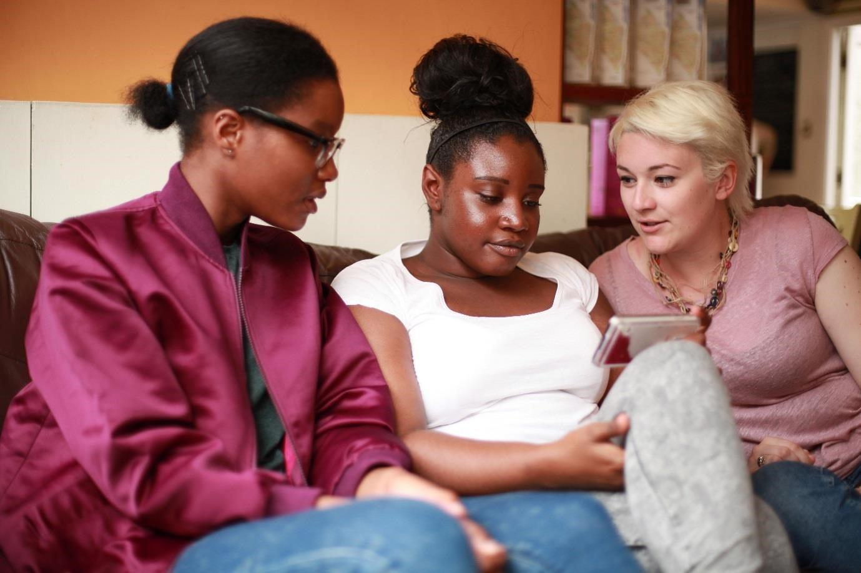

About The Mix
The Mix is a free, confidential support service for under 25s - making a massive difference to over two million young people in the UK each year. Whatever issue a young person is facing, The Mix is always there for them - online, over the phone or via social media. It connects young people to experts and their peers to talk about everything from money to mental health, from homelessness to jobs, from break-ups to drugs.
We are one of the eight charities forming the Duke and Duchess of Cambridge and Prince Harry’s Heads Together campaign to end stigma around mental health and will continue to work with them on raising awareness and providing vital help for people with mental health challenges. We work on high profile campaigns to change attitudes and raise awareness with the likes of Daniel Radcliff, Lady Gaga, and most recently Russell Brand. We work with TV shows like Hollyoaks to help young people understand sexual consent and big brands like River Island, Dixons Carphone and Lloyds Bank on everything from money to masturbation.
Today’s young people face an unprecedented range of challenges. They are possibly the first generation worse off in physical and emotional terms than their parents. The Mix’s mission is to ensure that every young person can make informed choices about their wellbeing – wherever and whenever they are: www.themix.org.uk
About Share Somewhere
Share Somewhere is a game-changing tool for communities who need spaces. The aim is to make it easier for people to find affordable spaces that can help them do great things with their communities. Equally, so many community group have underused spaces.
Share Somewhere is an online platform, open to all, that acts as the connection between those with spaces and those without. What makes Share Somewhere relevant to The Mix, is that often it is youth groups that are adversely affected by a lack of space for community groups.

Vision, Mission and Values
What we do: The Mix is here to take on the embarrassing problems, weird questions, and please-don’t-make-me-say-it-out-loud thoughts that people under 25 have in order to give them the best support through our digital and phone services.
Vision: To be the first point of contact for under 25s. We know that with the right skills and opportunities, you can take on anything that life throws your way.
Mission: To empower everyone under 25 in the UK with the knowledge, skills and confidence to make the right first steps in life. Life is hard, but support doesn’t have to be.
Values:
- Empowering - we lead, we train & support, we respect, we give space to grow, we give power to chose
- Brave - we innovate, we pioneer, we take risks, we tell it how it is
- Supportive - we listen, we encourage, we care, we’re understanding, we are empathetic
- Collaborative - we are open & transparent, we co-create, we respect, experience & expertise
- Proactive - we create situations, we make things happen, we get things done
- Non-judgemental - we do not judge, we do not criticise, we do not blame

Job Description

Job title: Marketing & Outreach Officer
Department: Marketing and Communications
Reporting to: Digital Marketing Manager

Overall purpose of the job:
The Marketing & Outreach Officer role is designed to support the marketing function at The Mix – helping us build relationships with key front-line service provides (on-the ground and digitally) as well as engaging with local youth influencers – to raise awareness and increase use of our local and national services in key regional areas. Alongside this you’ll be helping us grow our new service, Share Somewhere.
You will work closely with the Communications team to research and implement activity that helps us reach and support more young people across the UK. This will include both press outreach and relationships, influencer management and event creation and support.
Your work will help us reach and empower more young people and help them to make informed choices.
While this is an entry-level role, it would suit somebody with work or placement experience within a PR, journalist or event role; however, sales experience won’t be discounted.
Responsibilities will include:
- Research and manage local youth service providers and local service providers, whose young people will benefit from The Mix’s services, inclusive and focused upon Share Somewhere
- Creating and disseminating press releases for both The Mix and Share Somewhere
- Support with locally targeted activity that helps build links to our service – both digitally (link building), over the phone and in person
- Contribute and implement a two-year marketing strategy for Share Somewhere
- Create and manage a partner strategy for Share Somewhere
- Manage Share Somewhere’s social channels
- Maintain a database of local contacts and the status of The Mix’s relationship with them
- Support with the monitoring and reporting of our relationship building activity
- Build a network of volunteers to act as local champions of The Mix
- Manage any local volunteers and interns and keep continual contact with engaged influencers
- Research and attend relevant events and conferences in key regional areas, representing The Mix Work closely with our development team to identify potential local funders and partnership work
- Help the organisation build a picture of the issues affecting young people and youth trends by region

Person Specification:
The successful candidate will:
- Have experience writing press releases and creating media packs
- Have an understanding of how to build relationships
- Be comfortable meeting new people, initiating dialogue and engaging with people
- Understand social and email marketing and the connection between them
- Have a passion for The Mix’s work and helping young people

Desirable but not necessary experience:

- Procurement and handling suppliers (marketing materials, merchandise, etc.)
- LinkedIn marketing
- Organising events
- Understanding of link-building and SEO
- Presenting and relationship management across seniority levels
- Working with young people
- Working with influencers
- Degree in Journalism or similar

Terms and Conditions
Salary:  Contract:  Location:  Hours: | £20,000 - £23,000 DOE  Fixed Term Contract, initially for 6 months, but likely to be extended for the right candidate.  While based at our Baker Street office in London, flexible working is welcomed, with occasional location independent working required in line with business needs.  This post is full time Monday to Friday with 35 working hours a week. Some evening and weekend work will be required for which time of in lieu may be given.
To Apply | To apply, please send a CV, and covering letter addressing  the attributes outlined in the Job Description and Person Specification to workforus@themix.org.uk.

